The G20 and Sustainable Development

The Group of Twenty (G20) is an informal leaders’ level forum comprised of 19 nation states and the European Union (EU). The G20 consists of: Argentina, Australia, Brazil, Canada, China, France, Germany, India, Indonesia, Italy, Japan, South Korea, Mexico, Russia, Saudi Arabia, South Africa, Turkey, United Kingdom and United States. It was founded in 1999 as a forum of finance ministers and central bankers in response to economic crises which became increasingly global in nature as a result of the increasing speed of globalization in the late 1990s and early 2000s. A primary example of such a crisis was the 1997 Asian Financial Crisis which impacted large swaths of East and Southeast Asia, and it was feared that it might turn into a global crisis as a result of financial contagion. To overcome these crises and limit the economic fallout from them, the G20 was created as an institution for international cooperation and economic, financial, and fiscal policy deliberation with an understanding that no one government had the capacity to contain global economic crises alone. As a brainchild of then-finance minister of Canada, Paul Martin, and Lawrence Summers who was at that time, US Deputy Secretary of the Treasury, becoming Secretary of the Treasury in 1999, the G20 was discussed first at the G7 finance ministers meeting of 1999 in Cologne and was initially proposed to be held at the finance-minister level. Thus, from the onset, the forum’s main focus has been the governance of the global economy and the coordination of economic policy among members. In 2008, the G20 elevated to a leaders-level summit in response to yet another international economic crisis: the Global Financial Crisis (GFC) of 2008/09.
Currently the G20 convenes once a year with the members’ heads of government or state, finance ministers, foreign ministers and other high-ranking officials in attendance. Apart from the permanent members, other countries, international organizations and non-governmental organizations (NGOs) are invited to attend and observe the summits as well. Operating without any permanent staff, or a permanent secretariat, the G20’s incumbent chair of any given year establishes a temporary secretariat for the duration of its term. This secretariat is in charge of coordinating the group’s work, the organization of the summit and related meetings. Further, the G20 architecture includes issue-specific working groups comprised of relevant policy professionals from the member states. In total, there are thirteen such working groups. Examples include the development, education, health, energy transition and climate sustainability and trade and investment working groups. Apart from these broad working groups, there are also ones that are specifically pertaining to economic and finance issues. These are organized under the so-called Finance Track which are a series of meetings that are organized by the ministries of economy and finance. These meetings aim at investigating various aspects related to economic, financial, monetary and tax issues. Supporting these meetings are six working groups that include a Sustainable Finance, Africa Advisory, Infrastructure, and Global Partnership for Financial Inclusion working groups.
The G20’s permanent members account for roughly 60% of the world’s population, 80% of global GDP, 75% of global exports and around 50% of global land mass (G20 2021). While all 19 members are among the largest 31 economies measured by national GDP, size was but one factor that determined membership to the group when it was founded. The geographic diversity of the member states was crucial as well, with countries from most of the major regions being represented. Further, the G20 featured ‘an unprecedented successful attempt by developing countries to extend their participation in key institutions of global governance’ (Held 2010, 204). However, there have also been criticisms levelled at the G20 and the composition of its members specifically. Legitimacy and representation of the member states has been a criticism of the forum since its creation. Many argue that the group suffers from unfair exclusivity and an under-representation of African countries as only South Africa is a member.
As stated above, the initial focus of the G20 agenda was global financial sustainability and international economic policy coordination. However, since its inception, the scope of the agenda has increased gradually but significantly. Thanks to its unique composition of states from the Global North and South, the group was always well-positioned to work on issues of sustainable development and has discussed development issues at the leaders’ level since 2009.
In 2010, hosted by South Korea, the G20 recognized that “narrowing the development goals and reducing poverty are integral” to its broader goals which, ultimately, led to the development and approval of the “Seoul Development Consensus for Shared Growth” (Seoul Consensus) at that Summit. Originally defined as 10 key principles, the Seoul Consensus was a framework that aimed to assist the G20 nations as well as other global actors to improve the economic growth of less developed countries which was regarded as critical for these countries to achieve the UN Millennium Development Goals (MDGs) by 2015. The Seoul Consensus also incorporated a multi-year action plan to ensure the delivery of tangible results. Critically, the Seoul Consensus reflected a shift in approach from the previous Washington Consensus as it encouraged more state intervention – for example to invest in infrastructure – and put forward the notion that developing states should take the lead themselves when it comes to their economic development, as opposed to the previously applied top-down solutions from the Washington Consensus era. Further developed from its original form, the new Seoul Consensus consisted of six core principles:

- A focus on economic growth;
- A global development partnership;
- A prioritization of regional systemic issues;
- Increasing private sector participation;
- Ensuring complementarity with the actions of other global actors;
- An explicit outcome orientation; and

nine key pillars including infrastructure, human resource development, resilient growth and domestic resource mobilization.
As the Sustainable Development Goals (SDGs) were adopted as the successor to the MDGs in 2015 and were accompanied by the Paris Climate Agreement in the same year, the salience of discussions on sustainable development issues at G20 summits continued to increase. Issues of global development significance that have been discussed repeatedly by the group since 2015 include, but are not limited to, climate change, digitization, the economic empowerment of women, and migration. This is further reflected by the G20’s “Action Plan on the 2030 Agenda for Sustainable Development” which was put forward by the group in 2016 to affirm the G20’s efforts to contribute to the implementation of Agenda 2030 and the attainment of the SDGs. The plan identifies 15 sustainable development sectors (SDS) under which the existing collective efforts of the G20 can be subsumed (see Fig.1.).

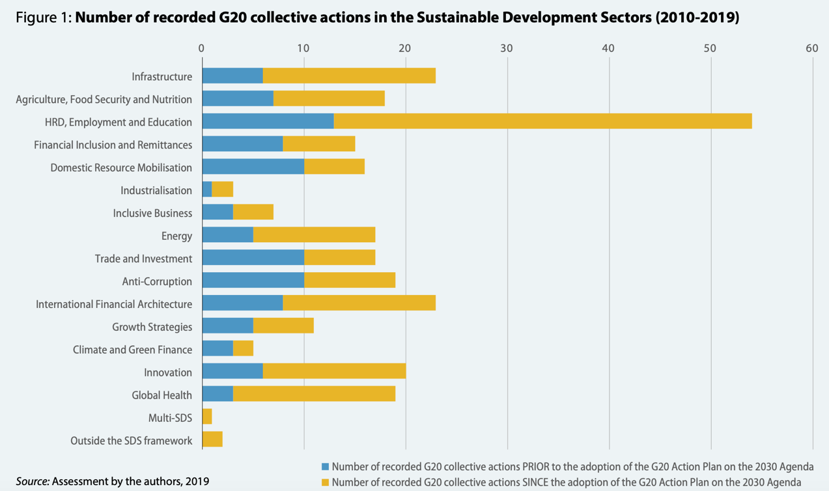
Fig. 1: Sustainable Development Sectors (OECD 2019)

Each SDS contributes to the achievement of one or more SDGs with the overall emphasis being put on three particular SDGs: Decent Work and Economic Growth (SDG8), Industry, Innovation and Infrastructure (SDG9) and Reduced Inequalities (SDG10) (Heinrich Böll Stiftung 2016).
Since the plan’s adoption in 2015, there have been yearly follow-ups on the Action Plan in the form of updates. In 2017, the first step towards putting the G20 Action Plan into practice was the “Hamburg Update: Taking forward the G20 Action Plan on the 2030 Agenda for Sustainable Development”. By adopting it, members agreed on additional concrete steps for implementation; established voluntary mechanisms for peer learning on successful approaches to implementing Agenda 2030; and launched two initiatives on resource efficiency and marine litter. The updates are crafted by the incumbent G20 chair and are thus reflecting its priorities. For the Hamburg Update, Germany’s priorities were resilience, sustainability, and responsibility with the agreed upon collective actions focussing on SDGs 8, 9 & 17.
This year, Italy will prioritize the financing of sustainable development as well as territorial development and the localization of the SDGs (OECD 2021).
In sum, the G20 has been an important player when it comes to global sustainable development and progress on Agenda 2030. The group was able to agree on concrete measures and targets to enhance global sustainability; cooperate on tax transparency; lower the cost of international remittances; increase female participation in the workforce; and enhance food security around the world. Finally, the group’s great global economic and political clout will continue to make it the prime forum for international policy deliberation in an effort to lead humanity on a path of sustainable development to 2030 and beyond.

